**Lab#12**

Object : Understanding the Adapter Pattern.

EXAMPLE of a System: (**ADAPTER PATTERN**)

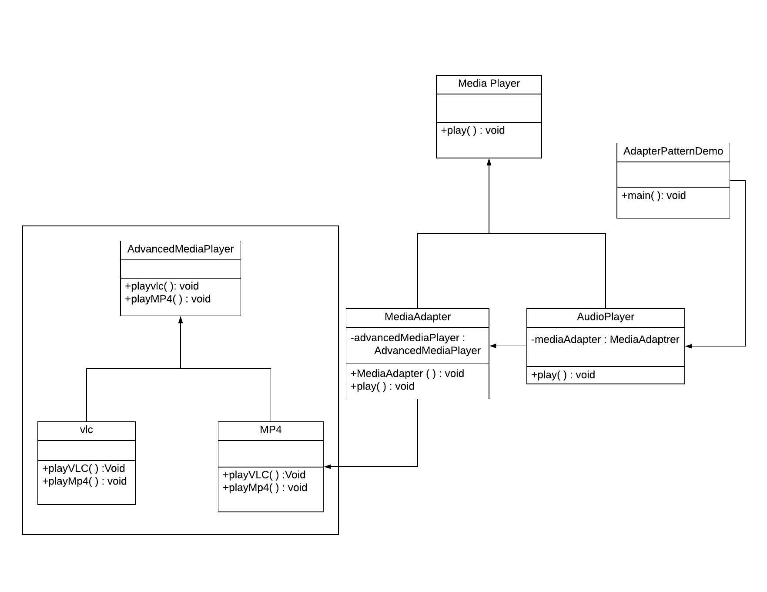

We are demonstrating use of Adapter pattern via following example in which an audio player device can play mp3 files only and wants to use an advanced audio player capable of playing vlc and mp4 files.

Why we need an **ADAPTER** for this system?

We want to make AudioPlayer to play other formats as well. To attain this, we have created an adapter class MediaAdapterwhich implements the MediaPlayer interface and uses AdvancedMediaPlayer objects to play the required format.

**KEY FEATURES:**

* AudioPlayer uses the adapter class MediaAdapter passing it the desired audio type without knowing the actual class which can play the desired format. AdapterPatternDemo, our demo class will use AudioPlayer class to play various formats.
* Without using MediaAdapter as an Adapter we cannot link these to  incompatible interfaces with eachother.